6940.0008 – Le Loxia – T2 – lot 55 – 1er étage

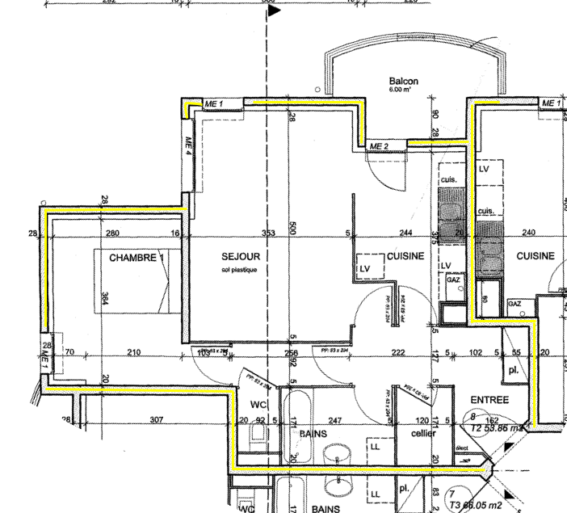

6940.8008 – Cave – lot 38 – RDC

